Topic: Dimension Reduction With PCA


Instructions:
Please share your answers filled in-line in the word document. Submit code separately wherever applicable.
Please ensure you update all the details:
Name: _g Rupak____________ Batch ID: ___07/05________
Topic: Principal Component Analysis

Grading Guidelines:
1. An assignment submission is considered complete only when correct and executable code(s) are submitted along with the documentation explaining the method and results. Failing to submit either of those will be considered an invalid submission and will not be considered for evaluation.
2. Assignments submitted after the deadline will affect your grades.

Grading:
Ans | Date |  |  | Ans | Date
Correct | On time | A | 100
80% & above | On time | B | 85 | Correct | Late
50% & above | On time | C | 75 | 80% & above | Late
50% & below | On time | D | 65 | 50% & above | Late
 |  | E | 55 | 50% & below
Copied/No Submission |  | F | 45

- Grade A: (>= 90): When all assignments are submitted on or before the given deadline
- Grade B: (>= 80 and < 90):
  - When assignments are submitted on time but less than 80% of problems are completed.
(OR)
  - All assignments are submitted after the deadline.

- Grade C: (>= 70 and < 80):
  - When assignments are submitted on time but less than 50% of the problems are completed.
(OR)
  - Less than 80% of problems in the assignments are submitted after the deadline

- Grade D: (>= 60 and < 70):
  - Assignments submitted after the deadline and with 50% or less problems.

- Grade E: (>= 50 and < 60):
  - Less than 30% of problems in the assignments are submitted after the deadline
(OR)
  - Less than 30% of problems in the assignments are submitted before deadline

- Grade F: (< 50): No submission (or) malpractice.

Hints:
- Business Problem
  - What is the business objective?
  - Are there any constraints?

- Work on each feature of the dataset to create a data dictionary as displayed in the below image:

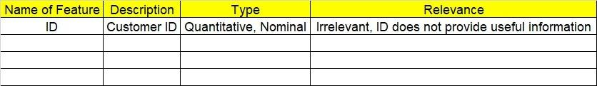
2.1 Make a table as shown above and provide information about the features such as its data type and its relevance to the model building. And if not relevant, provide reasons and a description of the feature.

- Data Pre-processing
3.1 Data Cleaning, Feature Engineering, etc.
- Exploratory Data Analysis (EDA):
  - Summary.
  - Univariate analysis.
  - Bivariate analysis.

- Model Building
  - Build the model on the scaled data (try multiple options).
5.2 Perform PCA analysis and get the maximum variance between components.
5.3 Perform clustering before and after applying PCA to cross the number of clusters formed.
5.4 Briefly explain the model output in the documentation.

- Write about the benefits/impact of the solution - in what way does the business (client) benefit from the solution provided?

Problem Statement: -
Perform hierarchical and K-means clustering on the dataset. After that, perform PCA on the dataset and extract the first 3 principal components and make a new dataset with these 3 principal components as the columns. Now, on this new dataset, perform hierarchical and K-means clustering. Compare the results of clustering on the original dataset and clustering on the principal components dataset (use the scree plot technique to obtain the optimum number of clusters in K-means clustering and check if you’re getting similar results with and without PCA).
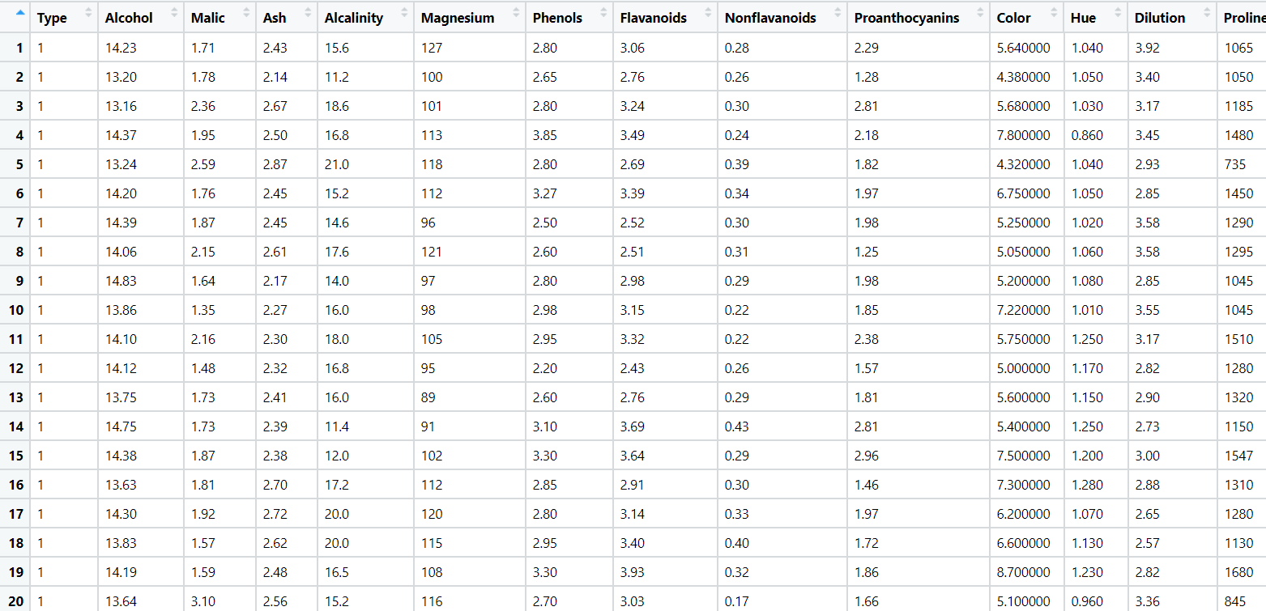

Hierarchical clustering

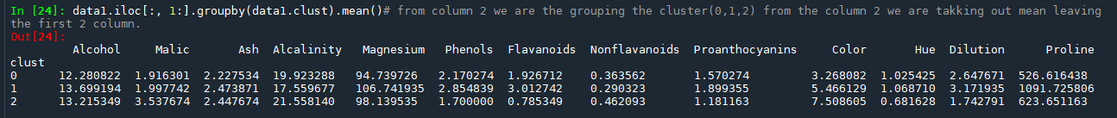
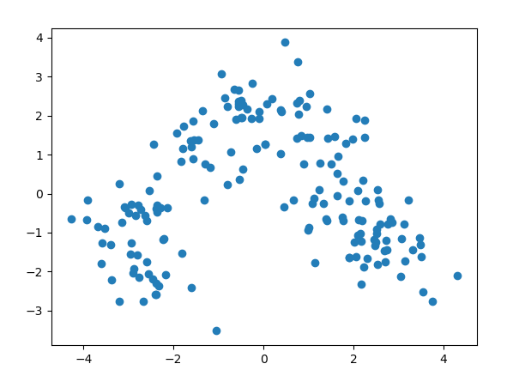

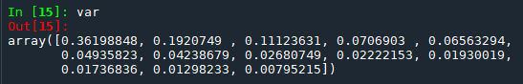

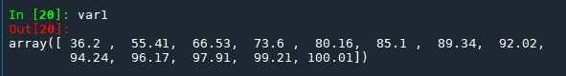
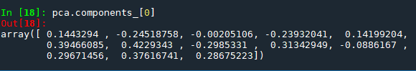
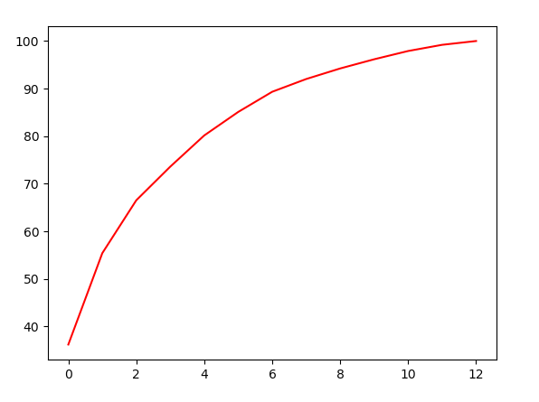

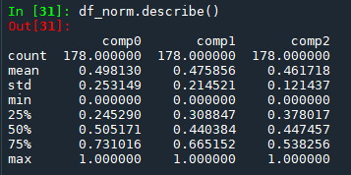

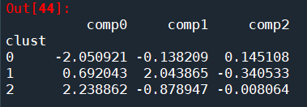

although it still holds the data but after transformatoin I cant able to compare the data but if we compare visually by scatter plot its giving the same output.

k means Clustring

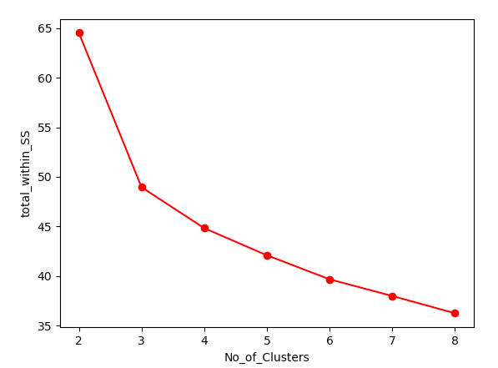

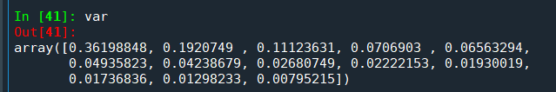

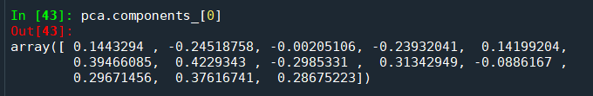

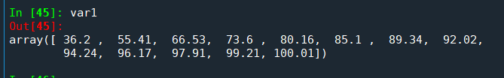

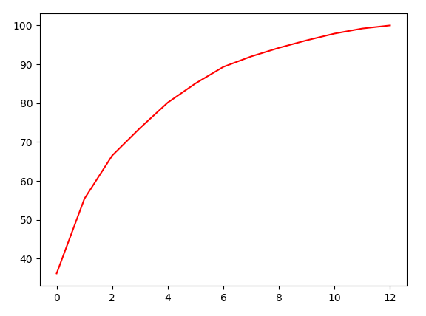

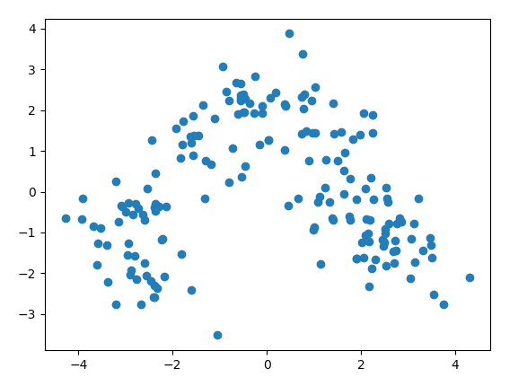

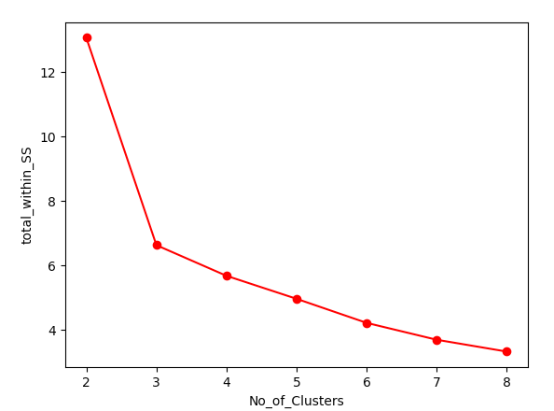

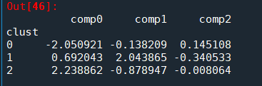

yes it is giving us the same result.

Problem Statement: -

A pharmaceuticals manufacturing company is conducting a study on a new medicine to treat heart diseases. The company has gathered data from its secondary sources and would like you to provide high level analytical insights on the data. Its aim is to segregate patients depending on their age group and other factors given in the data. Perform PCA and clustering algorithms on the dataset and check if the clusters formed before and after PCA are the same and provide a brief report on your model. You can also explore more ways to improve your model.

Note: This is just a snapshot of the data. The datasets can be downloaded from AiSpry LMS in the Hands-On Material section. 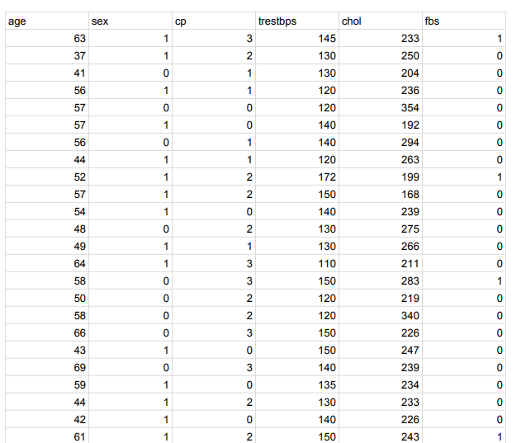

age: The person’s age in years
- sex: The person’s sex (1 = male, 0 = female)
- cp: The chest pain experienced (Value 1: typical angina, Value 2: atypical angina, Value 3: non-anginal pain, Value 4: asymptomatic)
- trestbps: The person’s resting blood pressure (mm Hg on admission to the hospital)
- chol: The person’s cholesterol measurement in mg/dl
- fbs: The person’s fasting blood sugar (> 120 mg/dl, 1 = true; 0 = false)
- restecg: Resting electrocardiographic measurement (0 = normal, 1 = having ST-T wave abnormality, 2 = showing probable or definite left ventricular hypertrophy by Estes’ criteria)
- thalach: The person’s maximum heart rate achieved
- exang: Exercise-induced angina (1 = yes; 0 = no)
- oldpeak: ST depression induced by exercise relative to rest (‘ST’ relates to positions on the ECG plot.)
- slope: the slope of the peak exercise ST segment (Value 1: upsloping, Value 2: flat, Value 3: downsloping)
- ca: The number of major vessels (0–3)
- thal: A blood disorder called thalassemia (3 = normal; 6 = fixed defect; 7 = reversible defect)
- target: Heart disease (0 = no, 1 = yes)

After hierarchail clustering data is

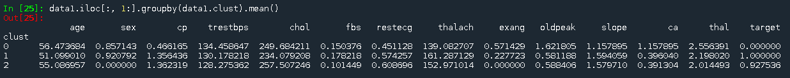
Clustering before pca

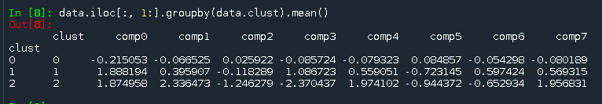
Clustering after pca

k means

